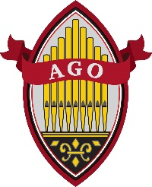
THE WINDCHEST
OMAHA CHAPTER OF THE AMERICAN GUILD OF ORGANISTS

DECEMBER 2021

DONATIONS
To raise funds for our Scholarship Fund, we are asking for donations when we meet. It is one way we can all support our fellow young organists.

New Mailing Address!
Omaha AGO has a new mailing address: PO Box 45062, Omaha, NE 68145. As we organize a Pipe Organ Encounter, it is important that personal information be sent to a secure location!
FROM THE DEAN

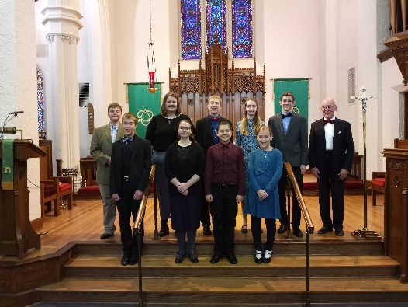
Pictured are organ students of Dr. J Gordon Christensen at their November 20th recital at St. Paul’s Lutheran Church in Council Bluffs. Four of the nine are members of the Omaha AGO. I was honored to hear this recital and very glad to meet Mary-Katherine, Brett, Augustine and Timothy. All students played two pieces, eight of the nine played one piece by Bach. Timothy Connor SPC concluded the program with Bach’s “Prelude and fugue in G Major” and Mulet’s “Carillon-Sortie”. This was an ambitous program - all played beautifully. Congratulations to all!
TOM TRENNEY gave us a lot to consider about how music affects many facets of our world at our November meeting. 20 members enjoyed in-person fellowship. Thanks to Gina Simpson and Ann Spangler for hosting.
SCHOLARSHIP FUND
Any time you would like to donate towards this fund, you could mail a check to Omaha AGO, PO Box 45062, Omaha NE 68145. We don’t have a December meeting but beginning again in January we will have our “Scholarship Fund” Box at our meetings to welcome your gifts large and small.
PROGRAMS Sub-Dean Steve Bartelt has begun planning programs for the 2021-2022 year, with the help of committee members Colleen Jeffrey, Ann Spangler, and Reggie Pifer. If you have ideas for them, please let Steve know.
CHAPTER ROSTERS. You should see the Omaha Chapter Roster now!!!
We have a wonderful group of young organists. We are not printing the roster this year, but you can find it on the web-site and it is easily printed, if you like a hard copy. When you are asked for a password, it
Pacific Hills FINE ARTS SERIES

PIANO CONCERT in the Fine Arts Series 3 PM on Sunday, Dec. 12th which is open to the public with a free will offering Information on this program is attached to the email that included this edition of The Windchest.

NEW MEMBERS!
Marissa Mathia
mmathia.music@gmail.com
11844 Jackson Road
Omaha, NE 68154

Quinton Corwin
quintoncbusiness@gmail.com
827 East 7th St
York, NE 68467
402-989-2271
is “2020-2021”. It is changing as up-dates come to us. This month we welcome new members Quinton Corwin and Marissa Mathia. Their information is listed elsewhere in the Windchest.
Many of you know Bev McCollum, organist at Morning Star Lutheran Church. She has retired and will be moving back east soon to be closer to her son. Bev has been a member and we wish her well.
NO MEETING IN DECEMBER I think you all have plenty to do. Keeping safe is still an important thing. As gatherings take place, be careful. This is a wonderful time of year when we may get to see family who live far away or host friends in our homes. We definitely have a role to play at our churches as we bring the Advent waiting, the Eve of birth, and the Christmas season of rejoicing stories to all who will come to listen. I know from past experience that you probably have planned a great deal and have already lived the story in your head and heart. Now it is time to bring it to life. May this time be special for each of you as you experience the joy of Christmas!
“We hear the Christmas angels the great glad tidings tell;
oh, come to us, abide with us, our Lord Immanuel!”
Jean Johnson
402-670-8177
jean.johnson.8@cox.net

UPCOMING PROGRAMS

Upcoming Chapter Programs . . .
December -- No program. Enjoy the busy Holiday season!

Sunday, January 9 – Relax with your fellow chapter members at a post-holiday social featuring fellowship and piano duets by two of our chapter’s newer members, Peggy Wolverton and Mary Norton. We meet in the Lakeside Village Grand Hall, 17475 Frances Street, from 3:00 to 5:00 p.m. Be sure to put the date on your calendar and watch the January Windchest for more details.

Saturday, February 5 – Presentation on African-American organ and choral music by Dr. Marques Garrett from UNL at First Christian Church with Ann Spangler as host, 10:00 a.m.

DO YOU HAVE AN IDEA FOR A CHAPTER PROGRAM?

Each of us probably has in the back of our minds an idea for a program that we always wished our chapter could present. Our program committee will soon begin to think about the 2022-2023 program year. Now would be a good time to share that idea with our program committee, and maybe it can become a reality. The program committee is chaired by our Sub-Dean Stephen Bartelt. Other members of the committee are Colleen Jeffrey, Reginald Pifer, and Ann Spangler.

Saturday, March 5 – Registration Workshop led by Mark Kurtz at First United Methodist Church, 10:30 a.m. to 2:00 p.m. with lunch provided. Open to all. Young organists are encouraged to attend.

Saturday, April 30 – “Pipes and Pizza,” for young organists (as well as not-so-young organists) at Countryside Community Church, hosted by Alex Ritter, 10:30 a.m. to 12:30 p.m.

Monday, May 23 – Dinner and Installation of Officers, First Presbyterian, Bellevue, 6:00 p.m. Elizabeth George from national AGO will be with us.

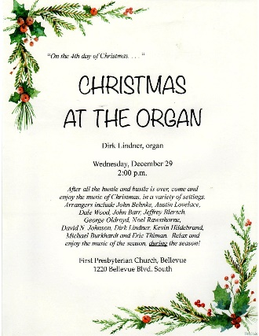
Free Membership
The AGO National Council is committed to membership recruitment, retention, and growth within our organization. During the Year of the Young Organist, July 1, 2021–June 30, 2022, any individual under the age of 30 can become a member or renew her/his membership for free as part of this program. Events and new initiatives will be held throughout the year.

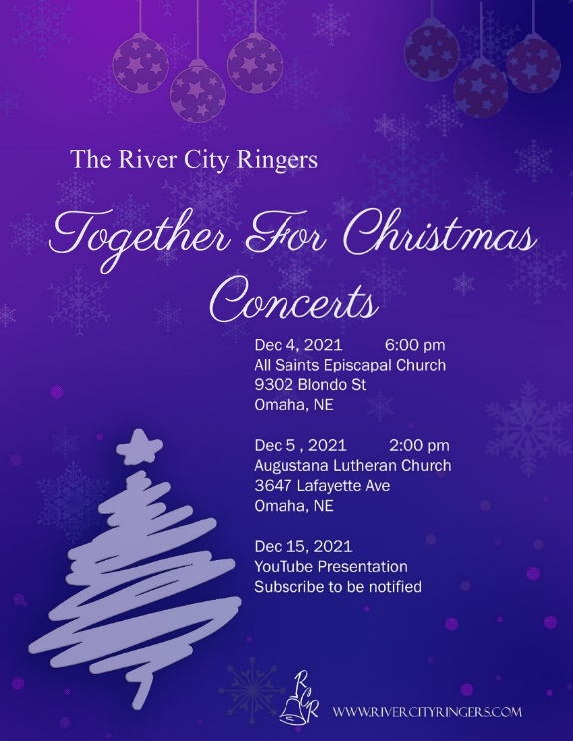

An Historical Note from Sub-Dean Stephen Bartelt . . .

I recently went through a large box of “memories” that my sainted mother had saved. Simply stated, the box held every program, news article, or piece of paper with my name on it, as only a loving mother could preserve. Among the items in the box was a copy of the December 1966 TAO. I have no idea how my mother acquired it, but the reason it was in the box was a small listing under “Choral Programs of Distinction” that reported on a concert by my college choir that included a composition I wrote, “How Long, O Lord” and, of course, my name. After viewing that entry I perused this copy from cover to cover and discovered some interesting things from 55 years ago.

- Cover price was 40 cents, a years subscription $3.00
- Only 34 pages, nothing in color, all black and white.
- A list of five conservatories included Eastman, Gregorian Institute of America, Guilmant Organ School, Pius X School of Liturgical Music, and BOYS TOWN, NEBRASKA! Amazing!
- A featured organ in this issue was the Schlicker at Mount Olive Lutheran in Minneapolis and the dedicatory programs by Paul Manz, as well as Manz’s description of the organ.
- A January US tour for Jean Langlais
- A full-page ad offering a recording “Virgil Fox Plays the Baldwin Organ.” for $2.00.
POE NEWS

We have received our first student registration! Information on hor to register is our our website at https://www.omahaago.org/poe

Please let Jeff Hoffman know at 402-317-8887 or at buildandencourage@gmail.com if you would like to help in any way!
- Choral music less than 50 cents and organ music less than $1.00

It was fascinating to peruse this 55-year-old publication of our organization. I will bring it along to our January post-holiday social for anyone interested to take a look at it.

AGO National Convention
Save the Dates: July 3–7, 2022 - Seattle, Washington
https://agoseattle2022.com/seattlepreview/

THANK YOU TO OUR ADVERTISERS!

